Technical Summary

Exploratory Analysis
Our work on this project started with some exploratory analysis of the dataset in the “historical_RAPTOR_by_player.csv” file. We wanted to gain an understanding of the data included in this dataset and take care of any clean-up that we felt was needed.
The original file contains 15 different variables and 19,159 observations. However, only 12 of the 15 variables are numeric. For our analysis, we wanted to focus on those numeric variables.
There was also a bit of redundancy among the variables in the dataset. The variables wins above replacement for the regular season (war_reg_season) and wins above replacement for the playoffs (war_playoffs) are both included in the calculation of another variable (war_total). So, we decided to drop both war_reg_season and war_playoffs from the dataset.
The dataset contains observations from every NBA season from 1977 to 2022. Those who are fans of the NBA know that the game has changed drastically over the years. Comparing individual players or the style of play from two different eras is like night and day in some respects. Because of this, we divided the dataset into four different eras: 1977-1987, 1988-1998, 1999-2009, and 2010-2022.
When looking at the summary of all the numeric variables, we noticed that the values for the variables possessions played (poss) and minutes played (mp) were much larger than the range of values for the other 10 numeric variables. It was important to note this discrepancy because it is a strong indicator that we should scale the data before performing certain types of analysis.
Another thing we learned about the dataset was that it contained observations for every single player who appeared in an NBA game during the timeframe (1977-2022). This means the dataset includes observations for players who played only one possession or only one minute during the course of an entire NBA season.
We felt that including the observations with a small sample size of playing time would not help our analysis. On the contrary, we thought that those observations could hinder our analysis. The small sample size of playing time could have skewed the results of the other metrics in the observation.
We decided to drop any observations where the minutes played (mp) was less than 99. This number was chosen a bit arbitrarily. We felt it was a good threshold because some of the metrics in the dataset are calculated per 100 possessions and all of the players above the threshold had greater than 100 possessions played (poss). In total, we dropped 1,896 observations from the dataset.
After dropping those observations, the range of the values for all of the raptor and predator variables (offense, defense, and total) got smaller. This tells us that the observations that had a smaller sample of playing time yielded some extreme values on both ends of the spectrum for those variables.

Principal Components Analysis
As we discussed in the non-technical summary, we chose Principal Components Analysis (PCA) as one of our lines of analysis because we suspected there was multicollinearity present in the dataset. Our initial analysis of the data confirmed that suspicion. Before running PCA, I removed the war_total variable from the dataset I was working with as I figured it was one of the best candidates to serve as the dependent variable in this analysis.
Based on the ranges of values for the variables in our dataset, I believe it would be best to run scaled PCA. However, I wanted to check unscaled PCA first to test this assumption. As expected, running unscaled PCA produced only one significant component, which accounted for 99.97% of the variance present in the data. As I discussed earlier, this result is due to the fact that two of our variables (poss and mp) have much larger values than the other 10 numeric variables.
If we run scaled PCA, we get much more useful results. You can see from the output below that the variance captured by the components is much more spread out.

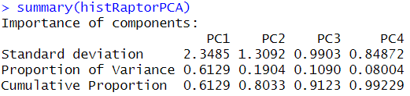

Next, we needed to choose how many of the components we would focus on. To do so, we looked at the scree plot. There are a few different methods we used to help determine the number of components we were going to focus on.
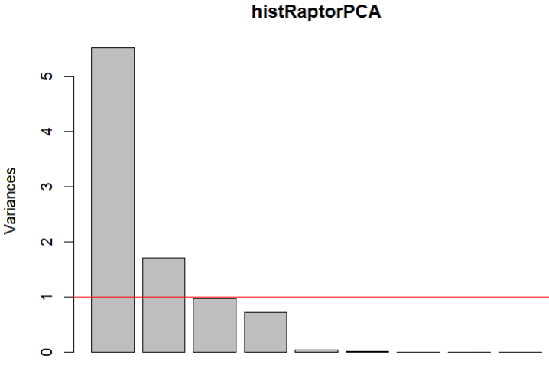

First, we looked for a “knee” in the scree plot, which is spotted by looking for a leveling off in variance. There does appear to be a knee after the fourth component. Next, since we are using scaled data, we looked for components that fell short of the variance = 1 threshold. The third component is just shy of that threshold and the fourth component falls well short of it.
At this point, the decision about the number of components we should choose was still unclear. So we ran Horn’s Parallel Analysis to help us make that decision.
In parallel analysis, we rerun PCA using a randomized dataset with the same dimensions as our dataset. We do this to see how many principal components would be selected from truly random data. The result of the analysis was that we should choose the first four principal components.
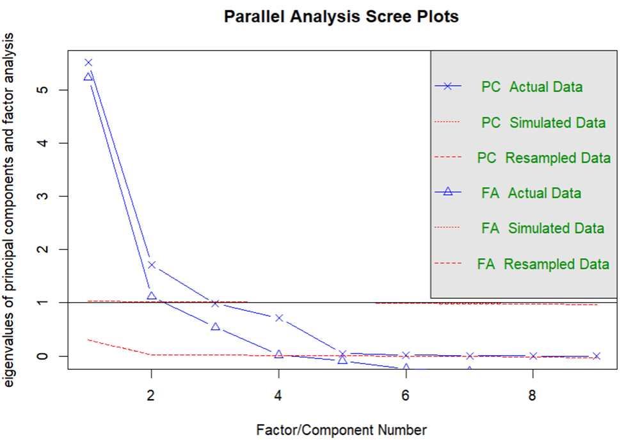

After choosing the number of principal components to select, the next step was to look at the make-up of each component and analyze their meaning. Each component can be represented by a linear combination of the variables in the dataset. We can look at the coefficients for each variable to gain an understanding of what each component is measuring.

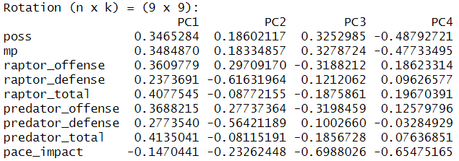

The first component (PC1) tells us about a player’s overall value based on the metrics in our dataset. The largest contributions to this component come from both of the total variables. It also has notable contributions from both of the offense variables, possessions played, and minutes played.
The second component (PC2) tells us if someone is more of a defensive player or more of an offensive player. The largest contributions to this component come from the two defense variables, which both have negative coefficients. This component captures a negatively correlated relationship between the defense and offense variables.
The third component (PC3) tells us how a player affects the pace of the game specifically from an offensive perspective. The largest contribution to this component comes from the pace impact variable. It captures a negatively correlated relationship between pace impact and both possessions played and minutes played. It also captures a positively correlated relationship between pace impact and the offensive variables.
The fourth component (PC4) is similar to PC3 in that it also tells us how a player affects the pace of the game. Its largest contribution comes from the pace impact variable, and it captures a positively correlated relationship between pace impact and both possessions played and minutes played.
Another tool that can help us understand the make-up of these components is PCA Plot. This function allows us to generate a plot of the variable coefficients for two adjacent components.

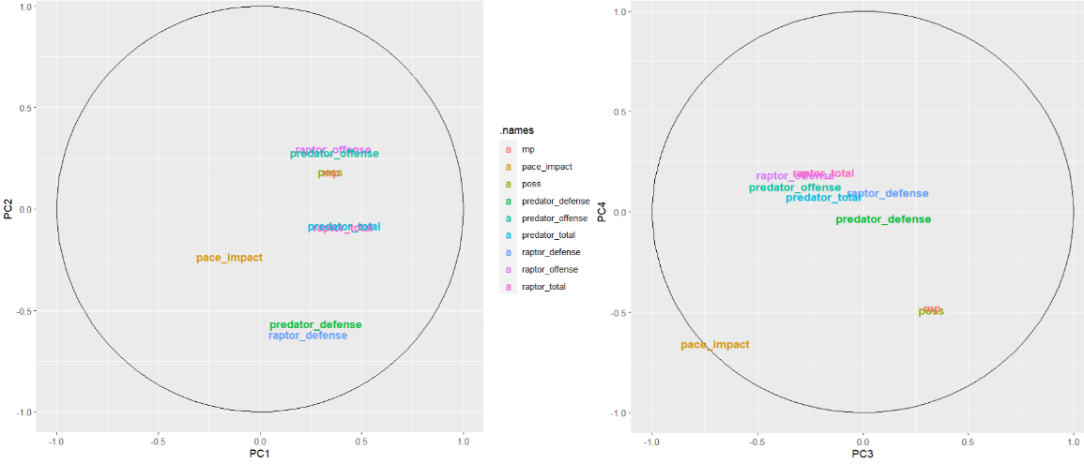

In the PCA Plots above, you will notice that there are pairs of variables that are close together in both plots. These are the same pairs of variables we identified when looking at the correlation matrix for this dataset. Unsurprisingly, the highly correlated variables have very similar coefficients in each of the four components.

